Changing Paging Controls from Bottom to Top
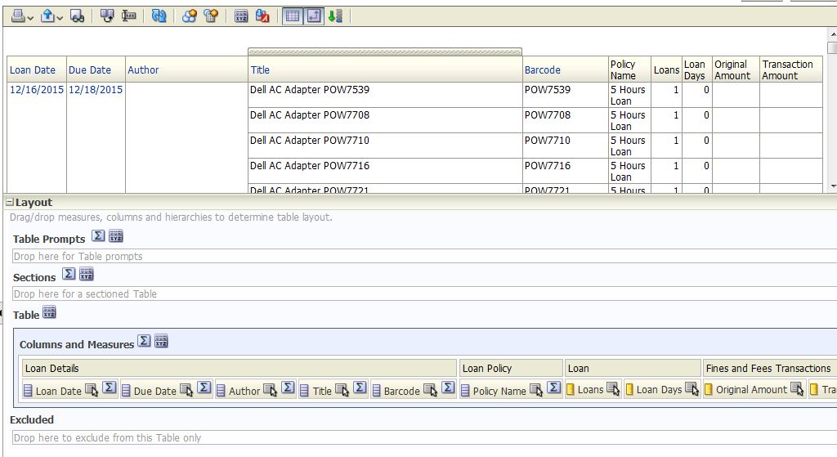In Layout view for an analysis, click on the Table View Properties in the persistent toolbar. The button has XYZ on it.

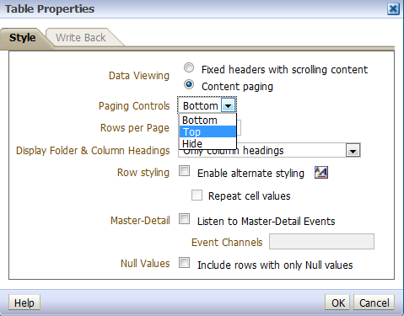
Click on the drop-down for Paging Controls and select Top. Click on the OK button…

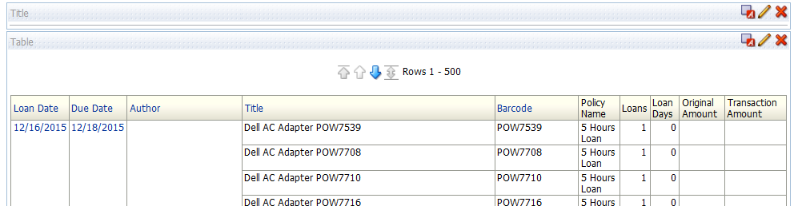
…to see the Paging Controls now located at the top of the analysis.

