Matthew:Users:apple:Dropbox (Univ. of Oklahoma):Helmerich-Collaborative-Learning-Center (1):NavApp:Working_Assets:NavApp_Images:GooglePlay_Icon.png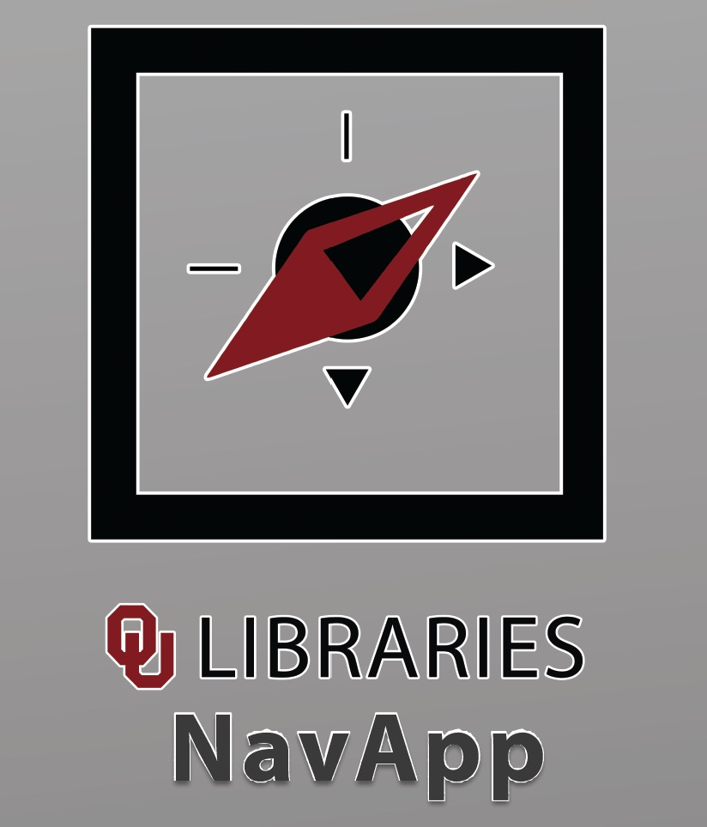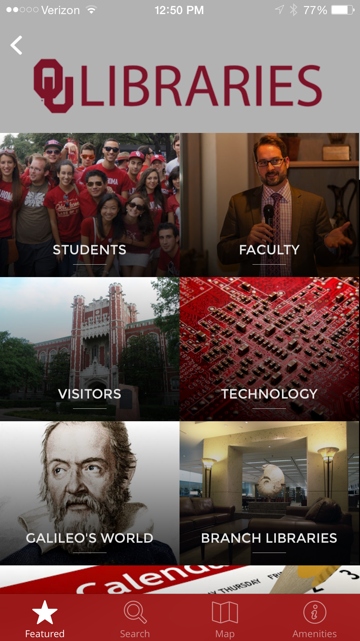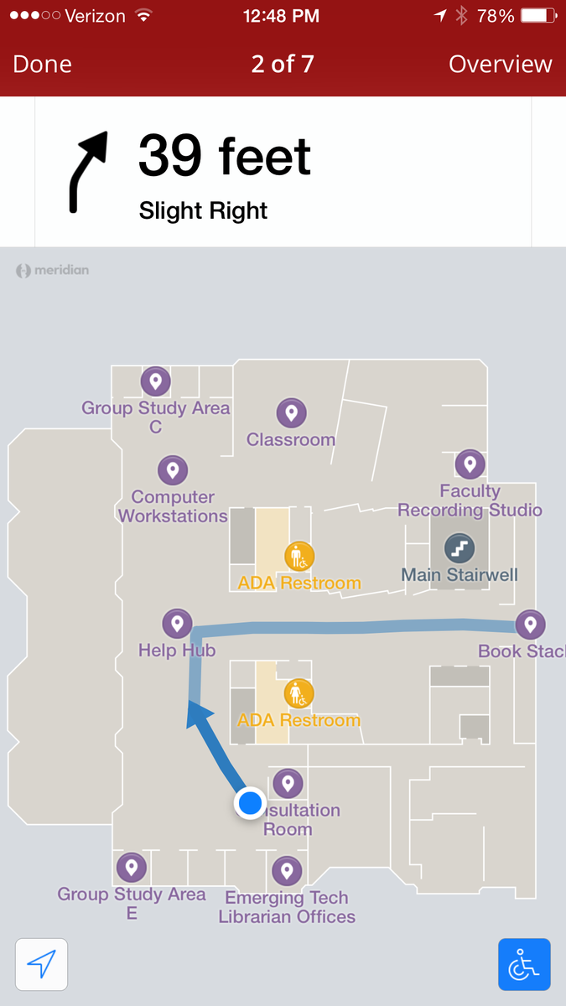

The *OU Libraries NavApp* **guides users in large indoor environments and provides location-based info** and push notifications with push notifications for tutorials, events and more.

The library-based pilot program will pave the way for a campus wide implementation of this cutting edge technology. **The launch of the OU Libraries NavApp is coincides with the opening of the *Galileo’s World* exhibition**, and showcases content from several partner galleries/exhibitions across the Norman campus.

Beyond innovative “indoor GPS” functionality, the tool provides:

* Turn**-by-turn navigation throughout campus.**
* Delivery of **hyper-local content**, corresponding to the your location on campus resources, indoors and out
* Routing & mapping utilities to **assist users with disabilities** as well as aid in emergency situations.

The OU Libraries NavApp **unifies our increasingly vast digital resources with our many physical services**.

Download the OU Libraries NavApp in the Apple Appstore and the Google Play store, and find out more **info at libraries.ou.edu/NavApp**